Kildare County Council

Statement to accompany Part 8 Public Consultation

Proposed Development of a New Machinery Yard & Regional Salt Barn at Jigginstown, Newhall, Naas , Co. Kildare - Planning Reference P82019.01

February 2019

Kildare County Council
Roads, Transportation and Public Safety
Level 4, Áras Chill Dara
Devoy Park
Naas, Co. Kildare

Contents

- Description of the proposed development.______________________________3

- Consistency with the proper planning and sustainable development of the area and the County Development Plan.____________________________________7

- Scheme Justification._______________________________________________8

- Impact of the proposed scheme.______________________________________9

- Pre-Part 8 Consultations.___________________________________________ 12

- Appropriate Assessment – Stage 1 Screening & Flood Risk Assessment______________________________________________________ 13

- Part 8 Consultations._______________________________________________14

The following is a report prepared in accordance with Part 8 of the Planning and Development Regulations, 2001 (as amended) providing information in relation to the provision of New Machinery Yard and Regional Salt Barn at Jigginstown, Newhall, Naas, Co. Kildare.

Description of the proposed development
Kildare County Council’s Roads, Transportation and Public Safety Department proposes to provide a New Machinery Yard and Regional Salt Barn at Jigginstown, Newhall, Naas, Co. Kildare.
The scheme will include the following elements:
Project Description
The proposed development is to replace the existing Machinery Yard facility currently located in Newbridge and from which Kildare County Council carries out a range of activities including:
- Coordination of winter maintenance operations,
- Coordination of surface dressing operations,
- Vehicle hire and purchase,
- Plant storage,
- Provision of vehicles for pothole repair and street sweeping,
- Fuel Storage for use by Kildare County Council as part of its operations,
- Salt Storage,
- Bitumen Storage,
- Workshop, including Vehicle re-spray facility
- Offices.
The proposed development will comprise two main elements, namely a new Machinery Yard to replace the existing facility in Newbridge and a new Regional Salt Barn. Ancillary perimeter and internal walls and fencing together with dedicated parking for staff and for operational vehicles will also be provided.
The new Machinery Yard, which will include workshop and office buildings, will serve as the new hub for the services and associated operations that are currently undertaken by Kildare County Council. These will include:
- Coordination of winter maintenance,
- Coordination of surface dressing operations, road repairs and street sweeping;
- Bitumen storage;
- Fuel Storage for own use. The fuel storage tank will be bunded. The design, inspection and certification of the bund will be in compliance with the EPA ‘Guidance Note on Storage and Transfer of Materials for Scheduled Activities’. The bunds will provide a storage capacity equivalent to 110% of the tank capacity of the tank it protects;
- Vehicle / plant repair, maintenance and management.
The Regional Salt Barn will provide storage for approximately 23,000 tonnes of salt for use by Kildare County Council and a number of other local authorities in the region as part of winter maintenance operations. The storage and distribution of the salt will be operated by Kildare County Council on behalf of the Department of Transport, Tourism and Sport.
The two main structures to be constructed on the site are –
- An Administration Building & 4-Bay Workshop. The Administration Building will consist of offices on the first floor (350 m²) over storage & ancillary accommodation on the ground floor (320 m²). The 4-Bay Workshop (630 m²) will be attached to the Administration Building.
- A 23,000 tonne (3,480 m²) Regional Salt Barn. An open-fronted lean-to (415 m²) is proposed at the side of the salt barn for the storage of snow ploughs, gritters and other equipment associated with the operation and management of the salt storage and distribution operation. A small welfare building (52 m²) is proposed for use by night time gritter drivers.
Ancillary structures / elements that also form part of the development are:
- Site Entrance and Weighbridges.
- Perimeter fences/walls and internal fencing to secure storage areas.
- Fuel storage and dispenser for own use.
- 30,000 litre raised bitumen tank with access stairs and platform.
- 2no. 10m x10m aggregate storage bays.
- 1no. covered 10m x 10m covered ancillary storage bay.
- Covered truck wash area with raised platform. Run-off from the truck wash-down will be segregated from surface water run-off. Water used in the wash-down will be recycled, with the recycling tank supplemented by mains water. Surplus run-off will go to the foul water network.
- Brine storage tankage.

Surface Water
The collection and discharge of surface water run-off will comply with the requirements of the Greater Dublin Strategic Drainage Study.
Surface water run-off will discharge to an existing open drain approximately 160 metres south west of the Site.
The permeability of sub-soils is relatively low and so it will not be possible to infiltrate run-off from heavier rainfall events to ground. However, measures will be incorporated into the surface water drainage network to maximise treatment of the ‘first-flush’ run-off from rainfall events. These will include the use of catchpit manholes with sumps to trap silts and the use of infiltration beds below the underground storage that is required for attenuated surface water. Hydrocarbon separators with integrated silt chambers will be installed immediately upstream of outfalls to the receiving drain. These separators will be designed in accordance with IS EN 858.
Truck Wash-Down
Run-off from the truck wash-down will be segregated from surface water run-off. Water used in the wash-down will be recycled; the recycling tank will be supplemented by mains water. Surplus run-off will go to foul water network.
Fuel Storage
Fuel storage tanks will be bunded. The design, inspection and certification of the bunds shall comply with the document ‘Guidance Note on Storage and Transfer of Materials for Scheduled Activities’ published by the EPA. The bunds will provide a storage capacity equivalent to 110% of the capacity of the tank it protects.
Wastewater
Wastewater from the development will discharge to a network of sealed sewer pipes discharging to a new pumping station within the Site, from which the wastewater will be pumped to an existing Irish Water sewer. Run off from the saltbarn aprons and associated areas will go to foul water network in winter when salt is being handled and to the surface water network during summer.
Soil Disposal
Surplus excavated material will be transported to licensed waste facilities for soil recovery such as those at Kildare Sand & Gravel Rathangan, N&C Enterprises Kilmeague and / or Walshestown Restoration Punchestown. These surplus soils will be handled in accordance with waste management regulations.
Full Details of Development
Full details of the proposed development can be found in the plans and particulars submitted with the application.
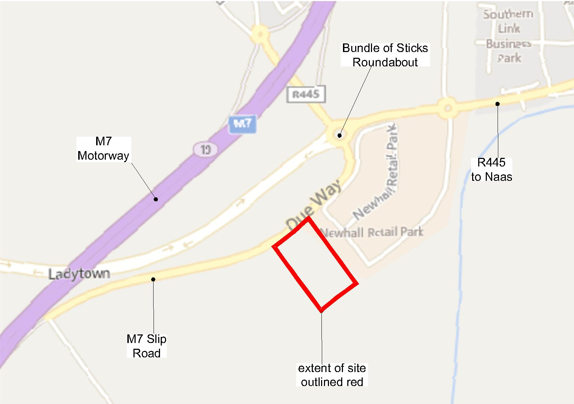

Fig. 1 Site Location Map
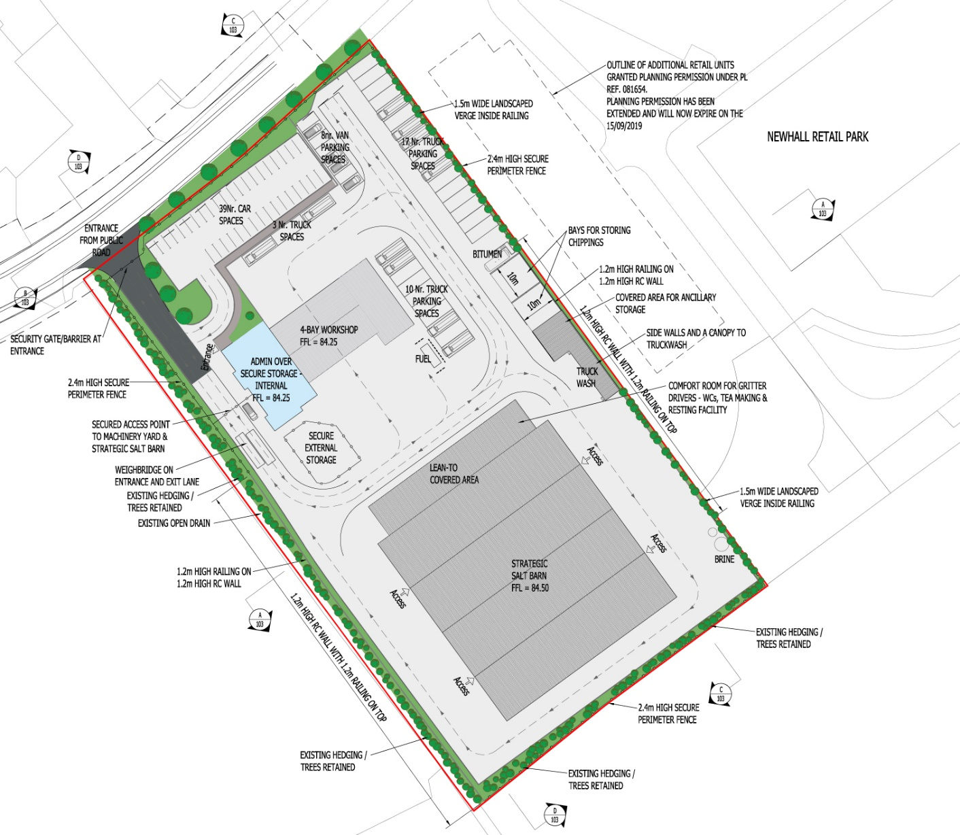
Fig. 2 Scheme Extents

Consistency with the proper planning and sustainable development of the area and the County Development Plan
The subject site was identified as a strategically important site and zoned NE1 (Industry/Warehousing) in the Kildare County Development Plan 2011-2017, which has since been superseded by the Kildare County Development Plan 2017-2023.
The purpose of this zoning objective was to provide sites for industrial, and in particular warehousing uses, at locations which are outside the built-up area of Naas, and which are, or could be made with appropriate road improvements, readily accessible to the national road network.
Table 18.2 of the Kildare County Development Plan 2011-2017 lists the various land uses that would be either permitted in principle, open for consideration or not permitted in the various land use zones identified in the plan. The proposed New Machinery Yard & Regional Salt Barn at Jigginstown, Newhall, Naas would comprise a number of uses including workshop, store/depot, utility structures and heavy commercial vehicle park as well as associated offices and car parking. The land use zoning matrix at Table 18.2 lists all of these uses as permitted in principle in areas zoned NE1 - Industry/Warehousing. Such uses are also considered to be permitted in principle on lands zoned NE1 (Industry/Warehousing) in the Kildare County Development Plan 2017-2023.
Therefore having regard to the policies and objectives of the Kildare County Development Plan 2011-2017 which identified the subject site as suitable for development of the type currently proposed, the policies and objectives of the Kildare County Development Plan 2017-2023, the pattern of development and adjacent land uses in the vicinity, it is considered that the proposed development would be consistent with the general development plan policies and objectives for this area.
Conclusion
The proposed development is consistent with the proper planning and sustainable development of the area.

Scheme justification
The existing Kildare County Council Machinery Yard / Roads Maintenance Depot is located on Military Road in the town centre of Newbridge and has been in operation for over 50 years. It is located in a retail / commercial zone, with constrained access to and from the facility at peak times. The site was previously owned by Irish Ropes and, since the 1960s buildings were not purpose built as a Road Maintenance depot, they present a number of challenges that were identified in a 2015 study undertaken on behalf of Kildare County Council. That study concluded that:-
- Comfort for users is poor,
- The facility is non-compliant with current:
  - Health & Safety Requirements,
  - Environmental Requirements,
  - Building Regulations, including:
    - Accessibility Requirements, and
    - Fire Regulations,
- The site is not secure and is an "eyesore" in the centre of Newbridge.
The study further concluded that the existing facility requires extensive upgrade and reconstruction to raise the standard to that of a purpose-built facility.
The site in Newbridge is likely to retain significant value and could potentially be developed, given its central location in the town centre.
The study therefore recommended that Kildare County Council consider developing a purpose built facility in a more appropriate location, rather than redevelop this site as a modern maintenance depot.
Following an assessment of the site of the proposed New Machinery Yard & Regional Salt Barn at Jigginstown, Newhall, Naas, it was determined that it met the following criteria:
  - Strategic location that provides easy access from the Machinery Yard Compound to all parts of the road network serving County Kildare and the overall region.
  - Availability of safe and adequate access /egress to and from the site;
  - Consistency with the general development plan policies and objectives for this area;
  - No land ownership issues;
  - Availability of adequate water supply together with means of waste water treatment and surface water disposal;
  - Availability of Utilities – electricity and communications.
The site at Jigginstown was thus selected as the optimal location. In recognition of the advantages of this site and its strategic location, the Department of Transport, Tourism & Sport subsequently undertook to provide funding for the construction of a Regional Salt Barn on the site.

Impact of the proposed scheme
Impact on Traffic
The Site abuts the Regional Road that currently leads onto the southbound lane of the M7 Motorway. Upon completion of the M7 Naas to Newbridge By-Pass Upgrade Scheme, which is currently under construction and scheduled for completion during 2019, this road will be downgraded to a lightly trafficked Local Road and will no longer provide access to the M7 Motorway.
A simple priority junction is proposed as the direct access to the development. Given that the public road will be lightly trafficked and the relatively low traffic flows generated by the development, this junction type is of sufficient capacity to serve the development and will therefore operate comfortably within its capacity.
Effectively all traffic generated by the development will travel via the Bundle of Sticks Roundabout, thus increasing traffic flows at the roundabout. The impact of these increased traffic flows on the operation of the roundabout was assessed in the Traffic Impact Assessment accompanying this planning application (Report Ref. 17032-R-TIA). The traffic assessment concluded that the proposed development will have a slight to moderate, permanent impact on the operation of the Bundle of Sticks Roundabout during peak AM and PM periods and an insignificant impact at other times of the day. Based on this conclusion, works to upgrade the capacity of the Bundle of Sticks Roundabout are considered neither necessary nor proportionate.
Beyond the Bundle of Sticks roundabout, trips generated by the proposed development will be divided between the three other arms of the roundabout. This dilutes the potential impact of the proposed development on the operation of these roads to the extent that assessment of the impact of the proposed development on roads beyond the Bundle of Sticks Roundabout is not considered necessary.
Internal Road Network
Traffic entering the Site will comprise heavy goods vehicles associated with the salt barn and work shop, and passenger cars associated with the staff and visitors.
A parking area for cars, with 39no spaces, is located close to the access. This allows the immediate segregation of passenger cars from larger goods vehicles. The surface to the car park and the length of access road shared by cars and heavy goods vehicles will be bituminous.
Heavy goods vehicles will proceed past the car parking area to the main yard area. Traffic movements within the main yard area will be delineated by markings and signs, which will be designed to minimise conflicting movements and provide clear unambiguous signals as to which movements have priority.
37no parking spaces are provided for gritter trucks. No dedicated parking bays are defined for articulated goods vehicles associated with the delivery and taking-away of salt; however areas are reserved adjacent to the salt barn to allow vehicles to queue while waiting to load or unload.
The surface of the main yard area will be concrete.
Roadmarkings will be used to delineate pedestrian routes through the yards area.
Impact on pedestrians and vulnerable road users
The proposed development does not include proposals for vulnerable road users outside of the site. However, this is acceptable given its location and function. It is noted that the proposed development will not preclude the provision of facilities for vulnerable road users on the future Rathasker Road.
Impact during construction
The following impacts during construction will be temporary:
Impact on landscape and visual amenity
The construction of the Project is not expected to have a significant effect on the visual amenity. There are no protected views within the area that will be affected by the proposed development
The development will alter the visual landscape, but boundary treatments as described in the proposal will effectively reduce landscape and visual impact and the resulting magnitude of change in landscape resource is low, consistent with minor and non-material alterations to character.

Impact on ecology
The development will not impact on any Natura 2000 sites.
There are no features within the area to be developed that have the potential to support roosting bats. Similarly the foraging and commuting opportunities for bats are negligible.
There will be a permanent loss of disturbed ground and immature woodland within the site. However, as this is a common and widely occurring habitat that doesn’t provide suitable breeding and / or foraging opportunities for mammals and birds, this loss will only be significant at the level of the Site. Overall, the residual impact on ecology will not be significant.

Impact on built and cultural heritage
The following information sources were checked as part of a desktop exercise to check for possible impact on built and cultural heritage:
- Record of Monuments and Places – Co. Kildare (RMP)
- Sites and Monuments Record (SMR) / Archive files of the Archaeological Survey of Ireland – www.archaeology.ie
- Topographical Files of the National Museum of Ireland (NMI)
- Excavations – Summary Accounts of Archaeological Excavations in Ireland – www.excavations.ie
- National Inventory of Architectural Heritage – www.buildingsofireland.ie
- Historic O.S. Map series – www.osi.ie
- Documentary and Cartographic Sources in Kildare County Library (Local History Section)
- Kildare County Development Plan 2017 – 2023 (KCDP)
In addition, the following reports were consulted:
- Cultural Heritage Report prepared by Claire Walsh, Archaeological Projects Ltd, included in the Newhall Retail Park - Environmental Impact Assessment prepared by Brady Shipman Martin (August 2003).
- Archaeological Monitoring Report – Newhall Retail Park; Archaeological Projects Ltd (September 2004).
Following completion of the desktop study, the subject proposed works areas and immediate environs were subjected to a site inspection/surface reconnaissance survey in early February 2019.
The two main impacts of a development of this nature, with respect to archaeological features, can broadly be described as Physical and Visual, which are discussed as follows:
Physical Impacts
There are no Recorded Monuments located within, or in the immediate environs of the subject development site, the closest being approx. 1000m to the southwest (KD019-035; Ringfort – Rath; Ladytown Td).
Part of the site was topsoil stripped as part of the development of the adjacent Newhall Retail Park, and such work was monitored by an archaeologist. Nothing of archaeological potential was uncovered by such works either within the area of the subject site in in the wider retail park area.
Given the above and the existing nature of the site, it is considered that the subject site is of very low archaeological potential for the discovery of subsurface archaeological features.
Visual Impacts
There are no Recorded Monuments located within, or in the immediate environs of the subject site. The nearest extant archaeological monuments are located a minimum of 1km from the site and, consequently, it is not envisaged that the development has the ability to impact on the settings of such monuments.

Overall Conclusion
It is expected that the proposed development will have some short-term negative impacts during construction but no longer-term impacts requiring mitigation are expected to arise.
An EIA screening assessment was been carried out in respect of the Scheme – the EIA Screening Report forms part of the documentation supporting this planning application.
The proposed development is below the thresholds for mandatory EIA. Having regard to the assessment described in detail in the EIA Screening Report, and in particular to the nature, scale and location of the proposed project, by itself and in combination with other plans and projects, the Scheme has been assessed as a sub threshold EIA development and it is concluded that an EIA is not required.

Pre-Part 8 Consultations

Pre-Part 8 consultations were undertaken with the following key stakeholders:
Kildare County Council

  - Roads, Transportation & Public Safety Department.

  - Planning Department.

  - Conservation Officer, Planning Department.

  - Heritage Officer, Planning Department

  - Water Services Department

  - Environment Department

  - Fire Services.

  - Health and Safety Department.

  - Architect’s Department.

  - Community and Culture Department.

Naas Municipal District Elected Members

A Pre-Part 8 consultation took place with the Naas Municipal District Elected Members prior to the Municipal District Meeting held on Tuesday 18th December 2018. All of the Municipal District Elected Members listed below were in attendance.

- Councillor Anne Breen
- Councillor Fintan Brett
- Councillor Billy Hillis (Mayor)
- Councillor Seamie Moore
- Councillor Sorcha O’Neill
- Councillor Robert Power
- Councillor Carmel Kelly
- Councillor Darren Scully

Appropriate Assessment - Stage 1 Screening

Stage 1 Screening was carried out in accordance with Article 6(3) and 6(4) of the Habitats Directive (Council Directive 92/43/EEC of 21 May 1992 on the Conservation of natural habitats and of wild fauna and flora).

This is transposed in Ireland primarily by the European Communities (Birds and Natural Habitats) Regulations 2011 (S.I. No. 477/2011) (hereafter the Birds and Habitats Regulations) and the Planning and Development (Amendment) Act, 2010 as amended.

An Appropriate Assessment (AA) is required if likely significant effects on European Sites arising from the proposed development cannot be ruled out at the screening stage, either alone or in combination with other plans or projects.

Following an examination and evaluation of the relevant information, including in particular, the fact that the proposed works will not impinge or impact on any European Sites, it is possible to rule out likely significant effects on all European Sites.

The AA screening process has identified that no European Sites are within the potential zone of influence of surface water discharges from the proposed development either during construction or upon completion of the works.

On the basis of the AA screening process, planning permission for the proposed development under Part 8 of the Planning and Development Regulations, 2001 (as amended) does not require an Appropriate Assessment with no requirement to proceed to Stage 2 Appropriate Assessment.

Flood Risk Assessment
A Site Specific Flood Risk Assessment (Report 17032-R-FRA Issue PL1) was carried out by Kilgallen & Partners in respect of the subject development and accompanies the planning application.
The findings of that report conclude the following:
Fluvial Flooding
No indicators of fluvial flood risk were identified.
Pluvial Flooding
Based on an assessment of indicators of pluvial flood risk, the Site is not considered at risk from pluvial flooding.
Groundwater
Based on an assessment of indicators of flood risk from groundwater, the Site is not considered at risk from groundwater flooding.
Based on the above and in accordance with the document ‘Planning System and Flood Risk Management – Guidelines for Planning Authorities (2009)’, a Detailed Site-Specific Flood Risk Assessment is not required.

Part 8 Consultations
It is intended that details of the proposed scheme will be referred to the following in conjunction with the public advertising of the proposals.
Naas Municipal District Elected Members
- Councillor Anne Breen
- Councillor Fintan Brett
- Councillor Deborah Callaghan
- Councillor Billy Hillis
- Councillor Seanie Moore
- Councillor Sorcha O’Neill
- Councillor Robert Power
- Councillor Carmel Kelly
- Councillor Darren Scully
Prescribed Bodies
The following relevant prescribed bodies were notified under Article 82 of the Planning and Development Regulations 2001 (as amended).
- National Transport Authority
- Transport Infrastructure Ireland
- National Tourism Development Authority
- Fáilte Ireland, Environment & Planning Unit
- Transport Infrastructure Ireland
- An Taisce
- Roads Safety Authority
- Health Services Executive
- Irish Water
- Heritage Council
- Department of Culture, Heritage, and the Gaeltacht (also sent by email)
- Minister for Culture, Heritage, and the Gaeltacht
- Department of Housing, Planning, Community and Local Government
- Minister for Housing, Planning, Community and Local Government
- Department of Transport, Tourism and Sport
- Minister for Transport, Tourism and Sport
- Department of Communications, Climate Action & Environment
- Minister for Communications, Climate Action & Environment
- An Comhairle Ealaoín (The Arts Council)
- Inland Fisheries Ireland
- Eir Group HQ
- An Garda Síochána, Garda HQ, Phoenix Park
- The Superintendent, Naas Garda Station
- ESB Head Office
- Health & Safety Authority
- Irish Wildlife Trust
- Bird Watch Ireland
- Eastern & Midland Regional Assembly (by email only)
- The Tree Council of Ireland
- National Parks & Wildlife Service
- IFA
- Gais Networks Ireland
- Ervia (Bord Gais
- Environmental Protection Agency
- Coras Iompair Eireann
- Bus Eireann
- Industrial Development Authority
- Department of Business, Enterprise & Innovation
- Minister for Business, Enterprise & Innovation
- Irish Aviation Authority
- Geological Society of Ireland

